購買 ESP8266 開發板
首先，你需要一塊 NodeMCU 或 D1 mini，或者其他 ESP8266 開發板。不管造型怎樣，功能都是一樣的。最容易購買和使用的是 NodeMCU，這又分成 V2 和 V3 兩種：
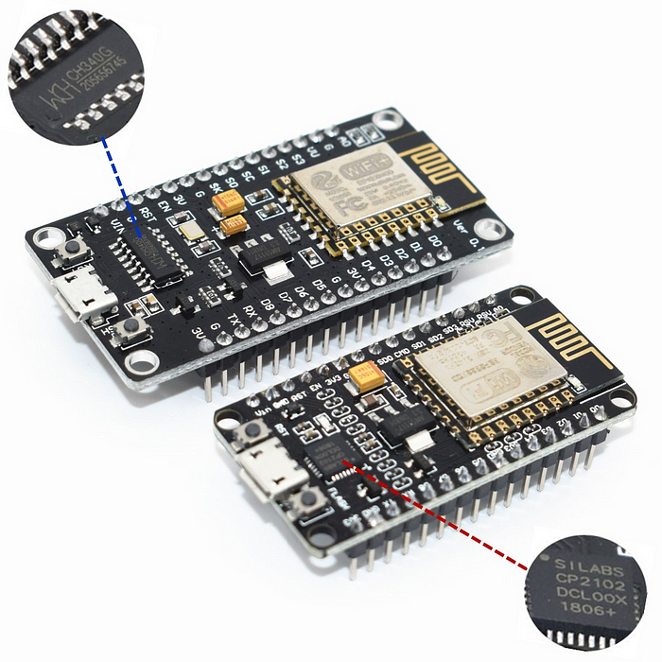
比較大的是 V3，較小的是 V2。
V2 和 V3 的差異只在尺寸和 USB 晶片不同而已（前者使用方形的 CP2102，後者則是長方形的 CH340）。有些 V2 或 V3 在網路上的價格僅有台幣百元出頭，這不會比 ESP-01S 貴上多少，而且又已經焊有針腳，買來就立即可用。

安裝nodeMCU驅動程式
對於Windows使用者,若無法自動偵測nodeMCU驅動程式,需要自行下載安裝COM埠驅動程式。

• nodeMCU V3 使用CH340G USB-to-UART橋接晶片組。
– USB-SERIAL CH340G 驅動程式下載
https://www.wch.cn/download/CH341SER_EXE.html

USB-to-UART CP2102 驅動程式下載
– https://www.silabs.com/documents/public/software/CP210x_Windows_Drivers.zip
檢查 NodeMCU 是否已和電腦正確連接
開啟「控制台」>「裝置管理員」>「連接埠(COM 和 LPT)」。
檢視序列埠是否有被啟用(你我的埠可能會不同)，如下圖
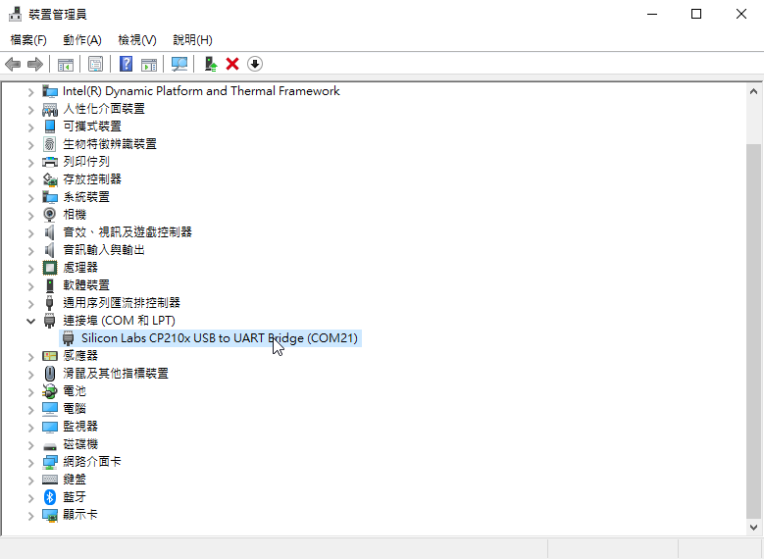
使用 Arduino IDE 撰寫程式
為了讓我們可以使用 Arduino IDE 來編寫程式，需要做一些設定，這個步驟只需做一次即可，以後啟動 Arduino IDE 都無需重覆設定。
Step1 開啟 Arduino IDE。
Step2 點擊「檔案」>「偏好設定」，將底下那一行字貼到「額外的開發板管理員網址：」右側欄位內
http://arduino.esp8266.com/stable/package_esp8266com_index.json
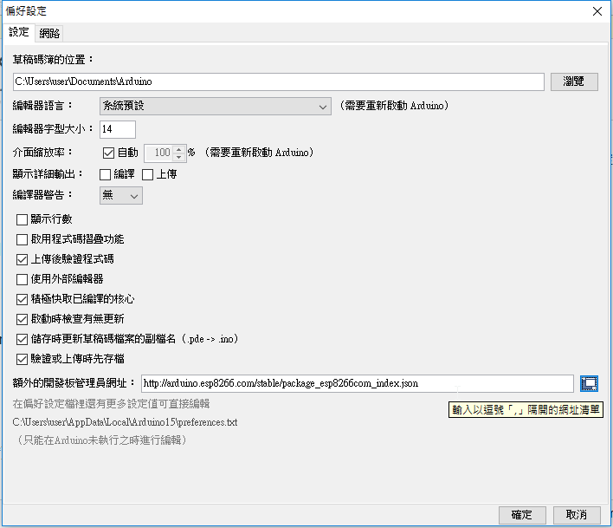
- NodeMCU, ESP-12E, ESP8266...
在台灣，想要使用 wifi 模組的話，通常會使用到另外一個開發板，這個開發板稱為 NodeMCU (node micro-controller unit, 微控制器單元)。 NodeMCU 開發板是架構在 ESP-12E 這個型號的板子上，而 ESP-12E 裡面的主要元件就是支援 wifi 的 ESP8266。 因為我們通常最需要的就是 wifi 模組，所以，通常就會通稱這種板子為 ESP8266 了！因此，我們用的開發板， 實際上應該稱為 NodeMCU 啦！也是因為這樣，你才會發現到，你所謂的『ESP8266』上面，其實是兩塊板子焊接在一起的！ 因為，這種擴展板上面確實包含了 ESP-12E，同時也加入了 ch340 或 cp2102 的 UART 晶片～
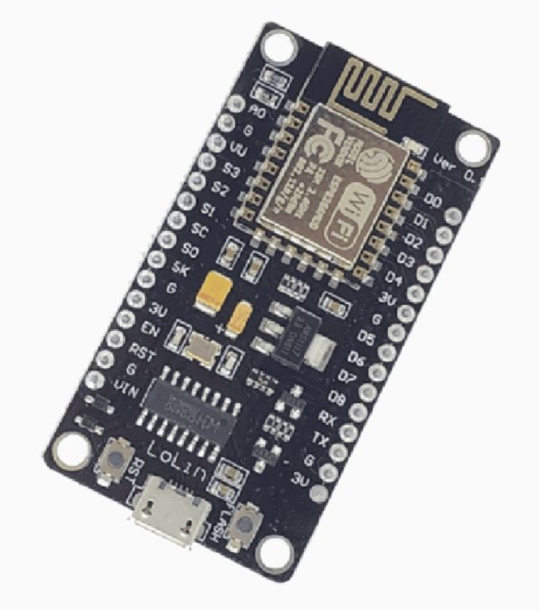 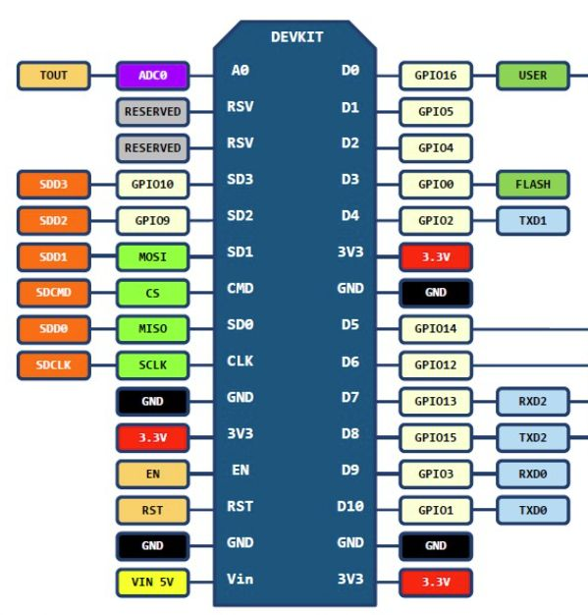
處理完畢之後按下確定，你就會在 IDE 環境的左下角出現提醒你可以安裝新開發板的訊息通知！如果略過也沒關係， 接下來直接到『工具』、『開發板：XXX』、『開發板管理員』，在搜尋列輸入 esp8266，看到的開發板資訊， 直接按下『安裝』後，等待幾秒鐘，就安裝好可以離開了！
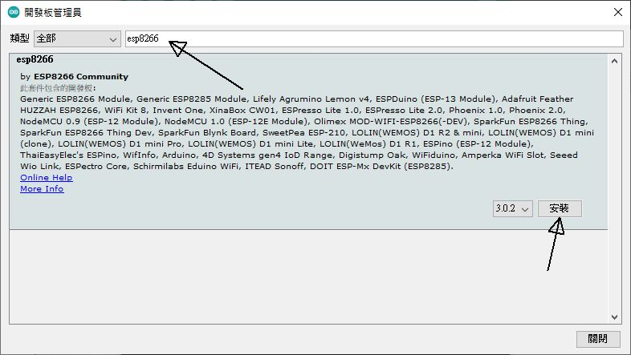 安裝開發板在 IDE 環境下
然後在『工具』、『開發板：XXX』、『ESP8266 Boards』、『NodeMCU 1.0(EPS-12E Module)』勾選！ 之後跟 arduino nano 一樣，選擇正確的序列埠，這樣就做好了開發板 IDE 環境的建置了！

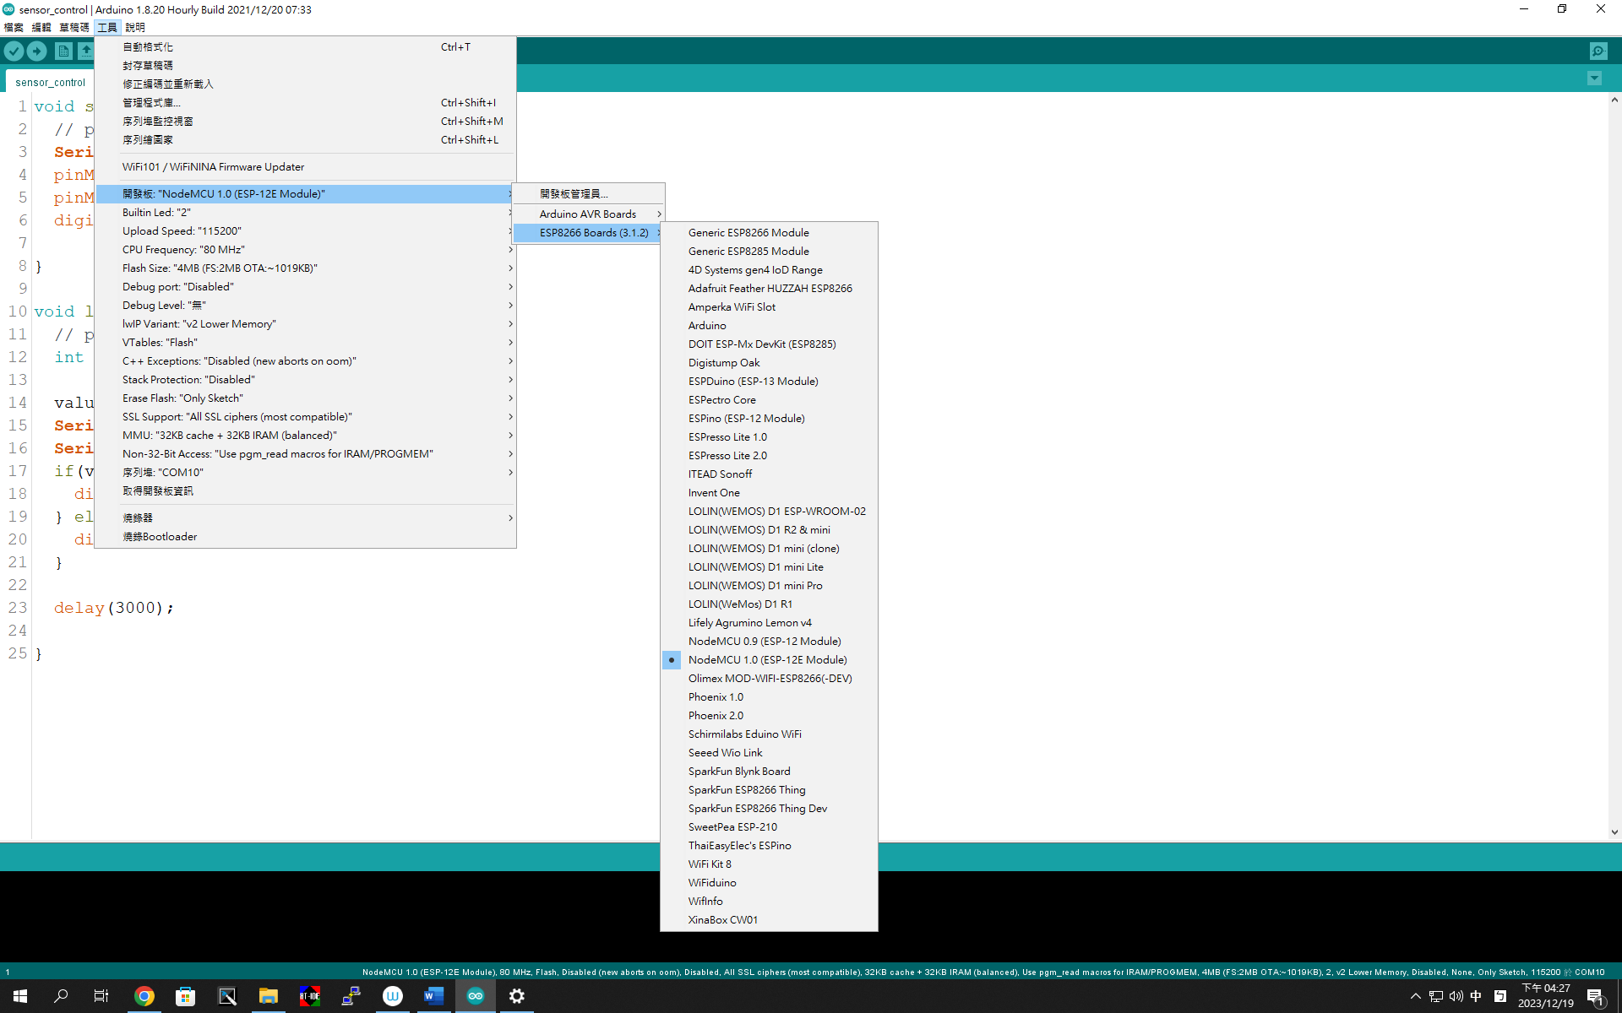

V2和V3最大差別在於USB的晶片不同
另外，由於V2和V3尺寸不同，所以擴展板是不能共用的哦！
NodeMCU可以使用Lua開發，也可以直接用Arduino IDE開發！

NodeMCU基本上就是一塊內建WiFi的Arduino Uno，小巧但威力強大，實測效能優於Arduino Uno、Mega2560等卡
基於ESP8266的NodeMCU開發板，具有GPIO、PWM、I2C、1-Wire、ADC等功能，結合NodeMCU 固件為您的原型開發提供最快速的途徑。

官方介紹 www . nodemcu . com

- 第一隻內建 LED 亮燈的 blink 程式
跟 arduino 一樣，ESP8266 也有個內建的 LED 燈，我們來測試一下，這個 LED 燈能不能閃爍呢！ 以確定 IDE 與 ESP8266 是可以連動的。從『檔案』、『範例』、『ESP8266』、『Blink』呼叫出 blink 程式， 將 delay 的延遲時間都改成 500 (0.5 秒)，之後就直接燒錄上傳，如果一切順利， 你應該會看到 ESP8266 上頭那顆藍色 LED 燈號會持續閃爍了！這就代表你的 ESP8266 開發板沒有問題！

10.2： 啟用 wifi 模組
就說 ESP8266 的重點在於 wifi 模組，要使用這個模組，當然就是先來掃描一下環境中的可用基地台了！ 從『檔案』、『範例』、『ESP8266WiFi』、『WiFiScan』翻出程式碼，主要是得要先修改鮑率，我們習慣使用 9600 呢！ 其他不用改！直接燒錄上傳，並打開終端界面，基本上就應該會看到如下的畫面才對喔！
Starting WiFi scan...
5 networks found:
00: [CH 01] [B8:27:EB:D8:AE:89] -43dBm * V RPi-vbird
....
同樣是可以看到我們先前架設好的 RPi-vbird 基地台喔！

- 連線到無線 AP
ESP8266wifi 模組畢竟與 WiFiNINA 不太一樣，雖然大部分的模組使用情況一樣，不過，並不是全部相同啊！ 所以，可能無法直接拿 code-wifi-connect 來修改...倒是可以從『檔案』、『範例』、『ESP8266WiFi』裡面的『WiFiClient』來修改！ 鳥哥稍微改一下內容，變成類似如下的程式碼：
#include <ESP8266WiFi.h>

char ssid[] = "RPi-vbird";
char password[] = "xxxxxxxxx";

void setup() {
Serial.begin(9600);

WiFi.mode(WIFI_STA);
WiFi.begin(ssid, password);

Serial.println();
Serial.print("Connecting to ");
Serial.print(ssid);
while (WiFi.status() != WL_CONNECTED) {
delay(500);
Serial.print(".");
}

Serial.println("WiFi connected");
}

void loop() {
printwifidata();
delay(5000);
}

void printwifidata() {
Serial.print("IP address: ");
Serial.println(WiFi.localIP());
Serial.print("GW address: ");
Serial.println(WiFi.gatewayIP());
Serial.print("DNS address: ");
Serial.println(WiFi.dnsIP());
Serial.print("Signal strength (RSSI): ");
Serial.print(WiFi.RSSI());
Serial.println("dBm");
}
檔名就取為 code-esp8266-connect，燒錄後上傳，如果一切順利，終端機會出現類似如下的情況：
Connecting to RPi-vbird.........WiFi connected
IP address: 192.168.33.236
GW address: 192.168.33.254
DNS address: 192.168.33.254
Signal strength (RSSI): -48dBm
- 取得網路校時
跟之前一樣，請整合 code-wifi-NTP 與剛剛的 code-esp8266-connect 讓你的 ESP8266 可以取得正確的時間！ 首先，在匯入模組的部份，需要有底下的資料：
#include <WiFiUdp.h>
#include <NTPClient.h>
WiFiUDP ntpUDP;
然後在全域變數的地方，得要宣告你的時間伺服器與時區的時差小時值
char ntpserver[] = "tw.pool.ntp.org";
int GMT = +8;
NTPClient ntpClient(ntpUDP, ntpserver, 3600*GMT);
在 setup 的函數當中，啟動 wifi 之前與之後，增加 LED 燈的開關。只是與 arduino nano 不一樣， 在 digitalWrite 的函數中，輸出 HIGH 反而是關燈，輸出 LOW 才是亮燈！這個相當有趣喔！
pinMode(LED_BUILTIN, OUTPUT);
digitalWrite(LED_BUILTIN, HIGH);
.....
digitalWrite(LED_BUILTIN, LOW);
同樣在 setup 函數最下方，得要讓 ntpClient 啟動才行：
ntpClient.begin();
ntpClient.update();
然後在 loop 函數中，就跟之前的 code-wifi-NTP 相同了！請列出相關的時間即可喔！
printwifidata();
Serial.println(ntpClient.getFormattedDate());
Serial.println(ntpClient.getFormattedTime());
Serial.println(ntpClient.getHours());
Serial.println(ntpClient.getMinutes());
Serial.println(ntpClient.getSeconds());
delay(5000);
其他程式保持不變，燒錄後上傳，應該就可以看到正確的時間輸出才對！
10.3： web server / web client 的應用 (GPIO 腳位對應)
基本上， esp8266 要做成與 arduino nano 相同的 web server / web client 方式幾乎相同！ 這是因為 esp8266wifi 與 wifinina 模組當中，使用的函數名稱幾乎相同的緣故！所以，你可以將前一章的 code-wifi-server1 相關內容彙整到 code-esp8266-server1 當中，只是要注意的是，ESP8266 能讀取的數位腳位名稱並不是使用 D1, D2 這樣的方式， 而是透過 GPIO 的腳位對應而來喔！相關對應的腳位有點像是這樣：
- D0: GPIO16
- D1: GPIO5
- D2: GPIO4
- D3: GPIO0
- D4: GPIO2
- D5: GPIO14
- D6: GPIO12
- D7: GPIO13
- D8: GPIO15
- D9: GPIO3
- D10: GPIO1

所以，如果如同前一章使用了 D5 腳位作為 LED 的連結時，那麼 led 的腳位就得要寫成 14 才對喔！

Servo control
Connecting Servo motor
If you have the same servo motor that I am using, you can follow the steps below to connect the servo motor to your board.
To connect the servo motor to your board follow the steps:
- Red (servo) on 3v
- Orange (servo) on a D port (eg D5)
- Brown (servo) on GND
Test if the servo motor is working by using standard code, follow the steps:
- Open Arduino software
- File > Examples > Servo (esp8266) > Sweep
- Indicate in the setup on which port your servo (orange wire) is located D5. By changing myservo.attach(2); to myservo.attach(D5);
- Upload the code and see if it's working
If the servo motor is working properly, go to your Arduino IDE and make sure that you have the correct board and port. You can find the board and port under tools in the Arduino IDE.

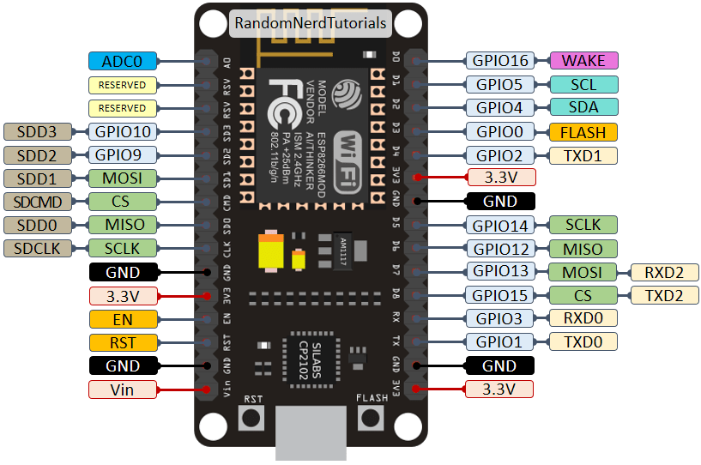

ESP8266WiFi library
ESP8266 is all about Wi-Fi. If you are eager to connect your new ESP8266 module to a Wi-Fi network to start sending and receiving data, this is a good place to start. If you are looking for more in depth details of how to program specific Wi-Fi networking functionality, you are also in the right place.

Introduction
The Wi-Fi library for ESP8266 has been developed based on ESP8266 SDK, using the naming conventions and overall functionality philosophy of the Arduino WiFi library. Over time, the wealth of Wi-Fi features ported from ESP8266 SDK to esp8266 / Arduino outgrew Arduino WiFi library and it became apparent that we would need to provide separate documentation on what is new and extra.

This documentation will walk you through several classes, methods and properties of the ESP8266WiFi library. If you are new to C++ and Arduino, don’t worry. We will start from general concepts and then move to detailed description of members of each particular class including usage examples.
The scope of functionality offered by the ESP8266WiFi library is quite extensive and therefore this description has been broken up into separate documents marked with :arrow_right:.

Quick Start
Hopefully, you are already familiar how to load the Blink.ino sketch to an ESP8266 module and get the LED blinking. If not, please use this tutorial by Adafruit or another great tutorial developed by Sparkfun.
To hook up the ESP module to Wi-Fi (like hooking up a mobile phone to a hot spot), you need only a couple of lines of code:
#include <ESP8266WiFi.h>

void setup()
{
Serial.begin(115200);
Serial.println();

WiFi.begin("network-name", "pass-to-network");

Serial.print("Connecting");
while (WiFi.status() != WL_CONNECTED)
{
delay(500);
Serial.print(".");
}
Serial.println();

Serial.print("Connected, IP address: ");
Serial.println(WiFi.localIP());
}

void loop() {}
In the line WiFi.begin("network-name", "pass-to-network") replace network-name and pass-to-network with the name and password of the Wi-Fi network you would like to connect to. Then, upload this sketch to ESP module and open the serial monitor. You should see something like:
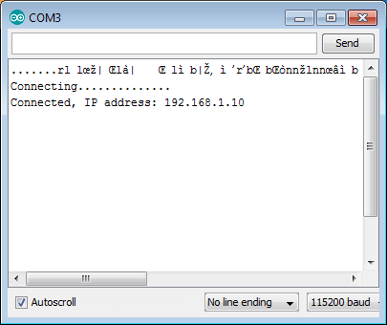
How does it work? In the first line of the sketch, #include <ESP8266WiFi.h> we are including the ESP8266WiFi library. This library provides ESP8266 specific Wi-Fi routines that we are calling to connect to the network.

The actual connection to Wi-Fi is initialized by calling:
WiFi.begin("network-name", "pass-to-network");
The connection process can take couple of seconds and we are checking for whether this has completed in the following loop:
while (WiFi.status() != WL_CONNECTED)
{
delay(500);
Serial.print(".");
}

The while() loop will keep looping as long as WiFi.status() is other than WL_CONNECTED. The loop will exit only if the status changes to WL_CONNECTED.
The last line will then print out the IP address assigned to the ESP module by DHCP:
Serial.println(WiFi.localIP());

If you don’t see the last line but just more and more dots ........., then likely name or password to the Wi-Fi network is entered incorrectly in the sketch. Verify the name and password by connecting from scratch to this Wi-Fi network with a PC or a mobile phone.
Note: if connection is established, and then lost for some reason, ESP will automatically reconnect to the last used access point once it is again back on-line. This will be done automatically by Wi-Fi library, without any user intervention.
That’s all you need to connect ESP8266 to Wi-Fi. In the following chapters we will explain what cool things can be done by the ESP once it’s connected.

Who is Who
Devices that connect to Wi-Fi networks are called stations (STA). Connection to Wi-Fi is provided by an access point (AP), that acts as a hub for one or more stations. The access point on the other end is connected to a wired network. An access point is usually integrated with a router to provide access from a Wi-Fi network to the internet. Each access point is recognized by a SSID (Service Set IDentifier), that essentially is the name of network you select when connecting a device (station) to the Wi-Fi.

ESP8266 modules can operate as a station, so we can connect it to the Wi-Fi network. It can also operate as a soft access point (soft-AP), to establish its own Wi-Fi network. When the ESP8266 module is operating as a soft access point, we can connect other stations to the ESP module. ESP8266 is also able to operate as both a station and a soft access point mode. This provides the possibility of building e.g. mesh networks.
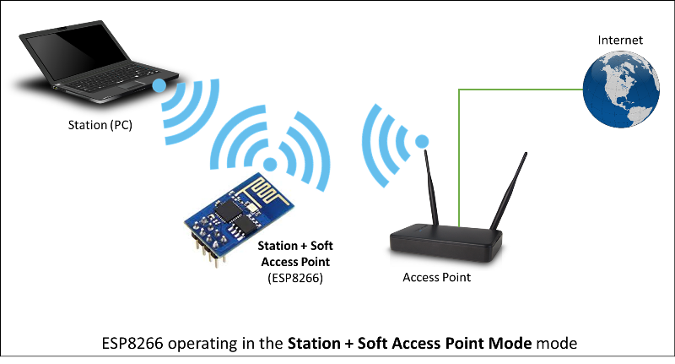

The ESP8266WiFi library provides a wide collection of C++ methods (functions) and properties to configure and operate an ESP8266 module in station and / or soft access point mode. They are described in the following chapters.

Class Description
The ESP8266WiFi library is broken up into several classes. In most of cases, when writing the code, the user is not concerned with this classification. We are using it to break up description of this library into more manageable pieces.
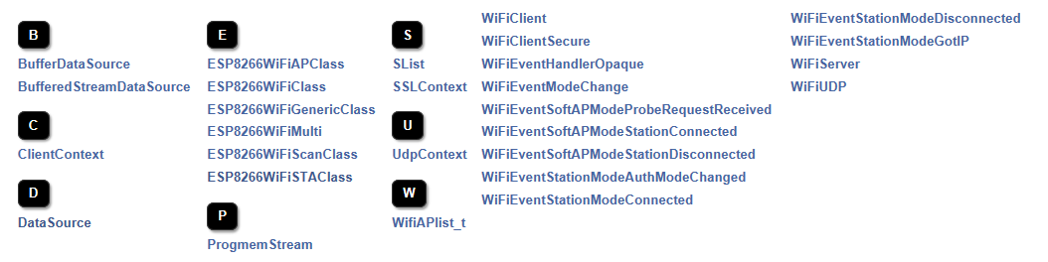
Chapters below describe all function calls (methods and properties in C++ terms) listed in particular classes of ESP8266WiFi. The description is illustrated with application examples and code snippets to show how to use functions in practice. This information is broken up into the following documents.

Station
Station (STA) mode is used to get the ESP module connected to a Wi-Fi network established by an access point.
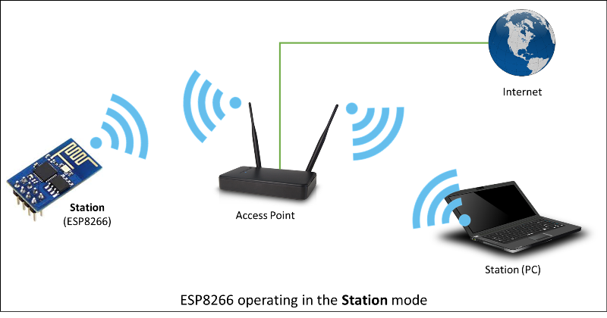

Station class has several features to facilitate the management of a Wi-Fi connection. In case the connection is lost, the ESP8266 will automatically reconnect to the last used access point, once it is available again. The same happens on module reboot. This is possible since ESP saves the credentials to the last used access point in flash (non-volatile) memory. Using the saved data ESP will also reconnect if sketch has been changed but code does not alter the Wi-Fi mode or credentials.
Station Class documentation
Check out separate section with examples.

Soft Access Point
An access point (AP) is a device that provides access to a Wi-Fi network to other devices (stations) and connects them to a wired network. The ESP8266 can provide similar functionality, except it does not have interface to a wired network. Such mode of operation is called soft access point (soft-AP). The maximum number of stations that can simultaneously be connected to the soft-AP can be set from 0 to 8, but defaults to 4.
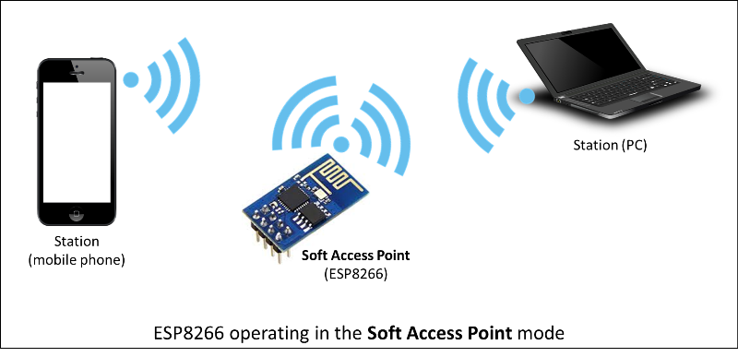

The soft-AP mode is often used and an intermediate step before connecting ESP to a Wi-Fi in a station mode. This is when SSID and password to such network is not known upfront. ESP first boots in soft-AP mode, so we can connect to it using a laptop or a mobile phone. Then we are able to provide credentials to the target network. Then, the ESP is switched to the station mode and can connect to the target Wi-Fi.
Another handy application of soft-AP mode is to set up mesh networks. The ESP can operate in both soft-AP and Station mode so it can act as a node of a mesh network.
Soft Access Point Class documentation
Check out the separate section with examples.

Scan
To connect a mobile phone to a hot spot, you typically open Wi-Fi settings app, list available networks and pick the hot spot you need. Then enter a password (or not) and you are in. You can do the same with the ESP. Functionality of scanning for, and listing of available networks in range is implemented by the Scan Class.
Scan Class documentation
Check out the separate section with examples.

Client
The Client class creates clients that can access services provided by servers in order to send, receive and process data.
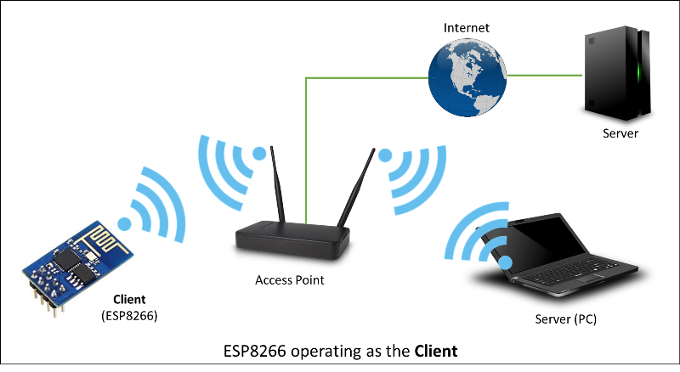
Check out the separate section with list of functions

WiFi Multi
ESP8266WiFiMulti.h can be used to connect to a WiFi network with strongest WiFi signal (RSSI). This requires registering one or more access points with SSID and password. It automatically switches to another WiFi network when the WiFi connection is lost.
Example:
#include <ESP8266WiFiMulti.h>

ESP8266WiFiMulti wifiMulti;

// WiFi connect timeout per AP. Increase when connecting takes longer.
const uint32_t connectTimeoutMs = 5000;

void setup()
{
// Set in station mode
WiFi.mode(WIFI_STA);

// Register multi WiFi networks
wifiMulti.addAP("ssid_from_AP_1", "your_password_for_AP_1");
wifiMulti.addAP("ssid_from_AP_2", "your_password_for_AP_2");
wifiMulti.addAP("ssid_from_AP_3", "your_password_for_AP_3");
}

void loop()
{
// Maintain WiFi connection
if (wifiMulti.run(connectTimeoutMs) == WL_CONNECTED) {
...
}
}

BearSSL Client Secure and Server Secure
BearSSL::WiFiClientSecure and BearSSL::WiFiServerSecure are extensions of the standard Client and Server classes where connection and data exchange with servers and clients using secure protocol. It supports TLS 1.2 using a wide variety of modern ciphers, hashes, and key types.
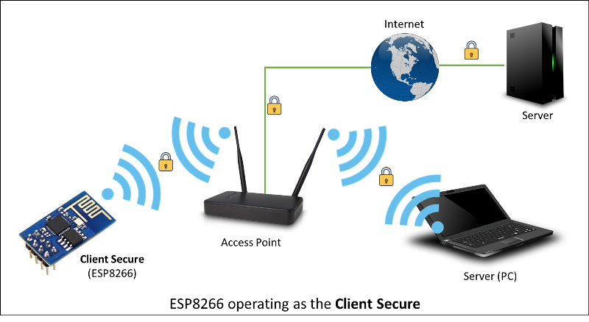

Secure clients and servers require significant amounts of additional memory and processing to enable their cryptographic algorithms. In general, only a single secure client or server connection at a time can be processed given the little RAM present on the ESP8266, but there are methods of reducing this RAM requirement detailed in the relevant sections.
BearSSL::WiFiClientSecure contains more information on using and configuring TLS connections.
BearSSL::WiFiServerSecure discusses the TLS server mode available. Please read and understand the BearSSL::WiFiClientSecure first as the server uses most of the same concepts.
Check out the separate section with examples .
Server
The Server Class creates servers that provide functionality to other programs or devices, called clients.
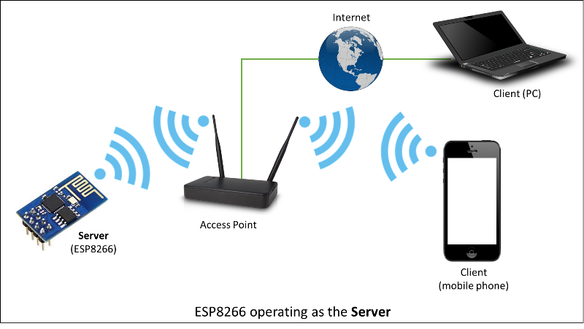
Clients connect to sever to send and receive data and access provided functionality.
Check out separate section with examples / list of functions.

UDP
The UDP Class enables the User Datagram Protocol (UDP) messages to be sent and received. The UDP uses a simple “fire and forget” transmission model with no guarantee of delivery, ordering, or duplicate protection. UDP provides checksums for data integrity, and port numbers for addressing different functions at the source and destination of the datagram.
Check out separate section with examples / list of functions.

Generic
There are several functions offered by ESP8266’s SDK and not present in Arduino WiFi library. If such function does not fit into one of classes discussed above, it will likely be in Generic Class. Among them is handler to manage Wi-Fi events like connection, disconnection or obtaining an IP, Wi-Fi mode changes, functions to manage module sleep mode, hostname to an IP address resolution, etc.
Check out separate section with examples / list of functions.

Diagnostics
There are several techniques available to diagnose and troubleshoot issues with getting connected to Wi-Fi and keeping connection alive.

Check Return Codes
Almost each function described in chapters above returns some diagnostic information.
Such diagnostic may be provided as a simple boolean type true or false to indicate operation result. You may check this result as described in examples, for instance:
Serial.printf("Wi-Fi mode set to WIFI_STA %s\n", WiFi.mode(WIFI_STA) ? "" : "Failed!");
Some functions provide more than just a binary status information. A good example is WiFi.status().
Serial.printf("Connection status: %d\n", WiFi.status());
This function returns following codes to describe what is going on with Wi-Fi connection:
- 0 : WL_IDLE_STATUS when Wi-Fi is in process of changing between statuses
- 1 : WL_NO_SSID_AVAILin case configured SSID cannot be reached
- 3 : WL_CONNECTED after successful connection is established
- 4 : WL_CONNECT_FAILED if connection failed
- 6 : WL_CONNECT_WRONG_PASSWORD if password is incorrect
- 7 : WL_DISCONNECTED if module is not configured in station mode
It is a good practice to display and check information returned by functions. Application development and troubleshooting will be easier with that.

Use printDiag
There is a specific function available to print out key Wi-Fi diagnostic information:
WiFi.printDiag(Serial);
A sample output of this function looks as follows:
Mode: STA+AP
PHY mode: N
Channel: 11
AP id: 0
Status: 5
Auto connect: 1
SSID (10): sensor-net
Passphrase (12): 123!$#0&*esP
BSSID set: 0
Use this function to provide snapshot of Wi-Fi status in these parts of application code, that you suspect may be failing.

Enable Wi-Fi Diagnostic
By default the diagnostic output from Wi-Fi libraries is disabled when you call Serial.begin. To enable debug output again, call Serial.setDebugOutput(true). To redirect debug output to Serial1 instead, call Serial1.setDebugOutput(true). For additional details regarding diagnostics using serial ports please refer to the documentation.
Below is an example of output for sample sketch discussed in Quick Start above with Serial.setDebugOutput(true):
Connectingscandone
state: 0 -> 2 (b0)
state: 2 -> 3 (0)
state: 3 -> 5 (10)
add 0
aid 1
cnt

connected with sensor-net, channel 6
dhcp client start...
chg_B1:-40
...ip:192.168.1.10,mask:255.255.255.0,gw:192.168.1.9
.
Connected, IP address: 192.168.1.10
The same sketch without Serial.setDebugOutput (true) will print out only the following:
Connecting....
Connected, IP address: 192.168.1.10

Enable Debugging in IDE
Arduino IDE provides convenient method to enable debugging for specific libraries.

What’s Inside?
If you like to analyze in detail what is inside of the ESP8266WiFi library, go directly to the ESP8266WiFi folder of esp8266 / Arduino repository on the GitHub.
To make the analysis easier, rather than looking into individual header or source files, use one of free tools to automatically generate documentation. The class index in chapter Class Description above has been prepared in no time using great Doxygen, that is the de facto standard tool for generating documentation from annotated C++ sources.
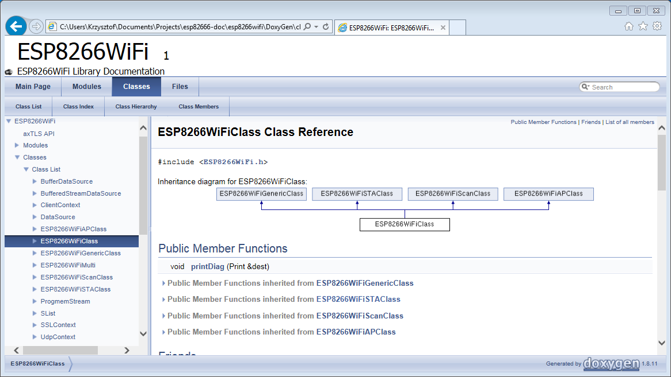
The tool crawls through all header and source files collecting information from formatted comment blocks. If developer of particular class annotated the code, you will see it like in examples below.
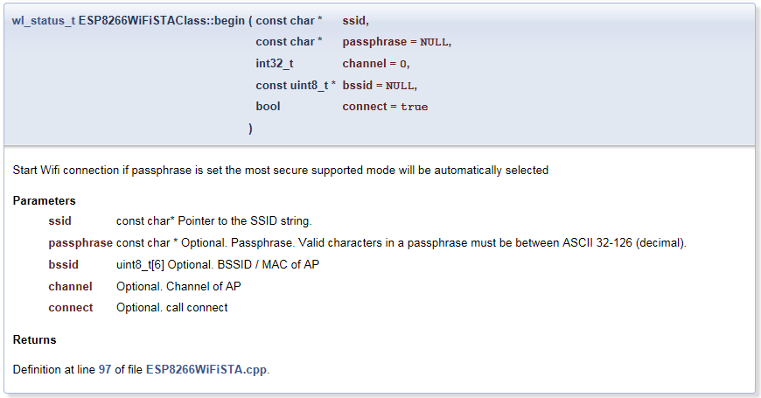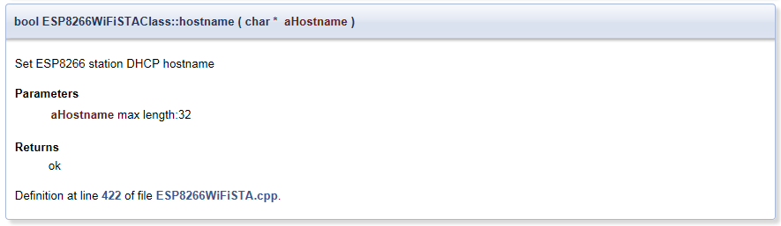

If code is not annotated, you will still see the function prototype including types of arguments, and can use provided links to jump straight to the source code to check it out on your own. Doxygen provides really excellent navigation between members of library.
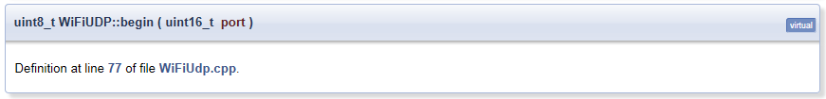
Several classes of ESP8266WiFi are not annotated. When preparing this document, Doxygen has been tremendous help to quickly navigate through almost 30 files that make this library.

Client Class
Methods documented for Client in Arduino
- WiFiClient()
- connected()
- connect()
- write()
- print()
- println()
- available()
- read()
- flush()
- stop()
Methods and properties described further down are specific to ESP8266. They are not covered in Arduino WiFi library documentation. Before they are fully documented please refer to information below.

flush and stop
flush (timeout Ms) and stop (timeout Ms) both have now an optional argument: timeout in millisecond, and both return a boolean.
Default input value 0 means that effective value is left at the discretion of the implementer.
flush() returning true indicates that output data have effectively been sent, and false that a timeout has occurred.
stop() returns false in case of an issue when closing the client (for instance a timed-out flush). Depending on implementation, its parameter can be passed to flush().

WiFiClient()
Description
Creates a client that can connect to to a specified internet IP address and port as defined in client.connect().

client.connected()
Description
Whether or not the client is connected. Note that a client is considered connected if the connection has been closed but there is still unread data.

#include <SPI.h>
#include <WiFi.h>

char ssid[] = "myNetwork"; // your network SSID (name)
char pass[] = "myPassword"; // your network password

int status = WL_IDLE_STATUS;
IPAddress server(74,125,115,105); // Google

// Initialize the client library
WiFiClient client;

void setup() {
Serial.begin(9600);
Serial.println("Attempting to connect to WPA network...");
Serial.print("SSID: ");
Serial.println(ssid);

status = WiFi.begin(ssid, pass);
if ( status != WL_CONNECTED) {
Serial.println("Couldn't get a wifi connection");
// don't do anything else:
while(true);
}
else {
Serial.println("Connected to wifi");
Serial.println("\nStarting connection...");
// if you get a connection, report back via serial:
if (client.connect(server, 80)) {
Serial.println("connected");
// Make a HTTP request:
client.println("GET /search?q=arduino HTTP/1.0");
client.println();
}
}
}

void loop() {
if (client.available()) {
char c = client.read();
Serial.print(c);
}

if (!client.connected()) {
Serial.println();
Serial.println("disconnecting.");
client.stop();
for(;;)
;
}
}

client.connect()
Description
Connect to the IP address and port specified in the constructor. The return value indicates success or failure. connect() also supports DNS lookups when using a domain name (ex:google.com).
client.connect(ip, port)
client.connect(URL, port)
Parameters
ip: the IP address that the client will connect to (array of 4 bytes)
URL: the domain name the client will connect to (string, ex.:"arduino.cc")
port: the port that the client will connect to (int)
Returns
Returns true if the connection succeeds, false if not.

#include <SPI.h>
#include <WiFi.h>

char ssid[] = "myNetwork"; // your network SSID (name)
char pass[] = "myPassword"; // your network password

int status = WL_IDLE_STATUS;
char servername[]="google.com"; // remote server we will connect to

WiFiClient client;

void setup() {
Serial.begin(9600);
Serial.println("Attempting to connect to WPA network...");
Serial.print("SSID: ");
Serial.println(ssid);

status = WiFi.begin(ssid, pass);
if ( status != WL_CONNECTED) {
Serial.println("Couldn't get a wifi connection");
// don't do anything else:
while(true);
}
else {
Serial.println("Connected to wifi");
Serial.println("\nStarting connection...");
// if you get a connection, report back via serial:
if (client.connect(servername, 80)) {
Serial.println("connected");
// Make a HTTP request:
client.println("GET /search?q=arduino HTTP/1.0");
client.println();
}
}
}

void loop() {

}

client.write()
Description
Write data to the server the client is connected to.
client.write(data)
Parameters
data: the byte or char to write
Returns
byte: the number of characters written. it is not necessary to read this value.

client.print()
Description
Print data to the server that a client is connected to. Prints numbers as a sequence of digits, each an ASCII character (e.g. the number 123 is sent as the three characters '1', '2', '3').
client.print(data)
client.print(data, BASE)
Parameters
data: the data to print (char, byte, int, long, or string)
BASE (optional): the base in which to print numbers:, DEC for decimal (base 10), OCT for octal (base 8), HEX for hexadecimal (base 16).
Returns
byte : returns the number of bytes written, though reading that number is optional

client.println()
Description
Print data, followed by a carriage return and newline, to the server a client is connected to. Prints numbers as a sequence of digits, each an ASCII character (e.g. the number 123 is sent as the three characters '1', '2', '3').
client.println()
client.println(data)
client.print(data, BASE)
Parameters
data (optional): the data to print (char, byte, int, long, or string)
BASE (optional): the base in which to print numbers: DEC for decimal (base 10), OCT for octal (base 8), HEX for hexadecimal (base 16).
Returns
byte: return the number of bytes written, though reading that number is optional

client.available()
Description
Returns the number of bytes available for reading (that is, the amount of data that has been written to the client by the server it is connected to).
available() inherits from the Stream utility class.
client.available()
Parameters
none
Returns
The number of bytes available.

#include <SPI.h>
#include <WiFi.h>

char ssid[] = "myNetwork"; // your network SSID (name)
char pass[] = "myPassword"; // your network password

int status = WL_IDLE_STATUS;
char servername[]="google.com"; // Google

WiFiClient client;

void setup() {
Serial.begin(9600);
Serial.println("Attempting to connect to WPA network...");
Serial.print("SSID: ");
Serial.println(ssid);

status = WiFi.begin(ssid, pass);
if ( status != WL_CONNECTED) {
Serial.println("Couldn't get a wifi connection");
// don't do anything else:
while(true);
}
else {
Serial.println("Connected to wifi");
Serial.println("\nStarting connection...");
// if you get a connection, report back via serial:
if (client.connect(servername, 80)) {
Serial.println("connected");
// Make a HTTP request:
client.println("GET /search?q=arduino HTTP/1.0");
client.println();
}
}
}

void loop() {
// if there are incoming bytes available
// from the server, read them and print them:
if (client.available()) {
char c = client.read();
Serial.print(c);
}

// if the server's disconnected, stop the client:
if (!client.connected()) {
Serial.println();
Serial.println("disconnecting.");
client.stop();

// do nothing forevermore:
for(;;)
;
}
}

client.read()
Read the next byte received from the server the client is connected to (after the last call to read()).
read() inherits from the Stream utility class.### Syntax
client.read()
Parameters
none
Returns
The next byte (or character), or -1 if none is available.

client.flush()
Discard any bytes that have been written to the client but not yet read.
flush() inherits from the Stream utility class.### Syntax
client.flush()

client.stop()
Disconnect from the server### Syntax
client.stop()

